Ruiyan(Maggie) Huang

Physics3

Jaime Gonzalez

9/16/2018

**Effect of Length of Pendulum on its Period**

# Introduction

The purpose of the experiment is to examine the following formula: determine whether the period of a pendulum is affected by its length, calculate **g** the acceleration due to gravity, and compare it with the real value of **g**.

**T = 2π√(L/g) 🡪**  T2 = 4π2L/g

(**L** is the length of a pendulum, T is the period of oscillation).

The **hypothesis** of the experiment is that the period of pendulum is affected by the length of the string because the longer the length, the longer the distance the pendulum needs to travel, and thus more time for one period.

And by plotting a graph of T2 (y-axis) against L (x-axis), the gradient of the straight line should be equal to 4π2/g, according to the following formula T2 = 4π2L/g, and the g value should be close to the actual value, which is 9.81 m.s-2

Independent variable: Length of the string

Dependent variable**:** Period of the pendulum

Controlled variable**:** Mass of the metallic ball and amplitude of the pendulum.

The control of variables**:**

Independent variable: Use a range of lengths from 0.4 to 1 m in increments of 0.1m.

Dependent variable: measure 10 periods of pendulum each time

Controlled variable: use the same metallic ball and the same angle to the equilibrium when pendulum is released.

# Procedure

### Materials

* Metallic ball,
* String,
* Stand,
* Clamp,
* Scissors,
* Meter stick,
* Timer,
* Triangle ruler,
* Vernier caliber

### Methods

1. Gather all the materials.
2. Use scissors to cut about 2m of the string and tie it to the ball.
3. Use Vernier caliper to measure the radius of the ball **r**.
4. Starting from the connection of the ball, measure out and mark the range of lengths from (0.4-r) m to (1-r) m in increments of 0.1m.
5. Coil and tie the other end of the string to the clamp. Make sure the total length (from the center of the pendulum to the clamp) is 40cm.
6. Put the stand at the edge of the table.
7. Hold the pendulum up 30° to its equilibrium position by using the triangle ruler (diagram A), and also make sure the string is perpendicular to the clamp.（diagram B）
8. Release the pendulum.
9. Have a partner start recording the time when it goes right past its equilibrium position, and stop recording the time after the pendulum go back and forth 10 times.
10. Repeat Step 5 to 7 for three times.
11. Change the length of the string to different length ranging from (0.5-r) m to (1-r) m, and repeat Step4 to 7.
12. Record all the data in a table.

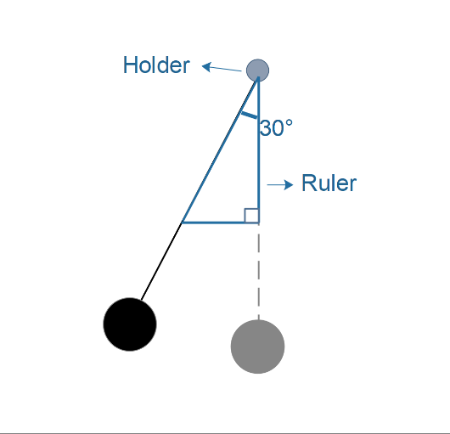Diagram A: front view Diagram B: left view

Clamp

Clamp

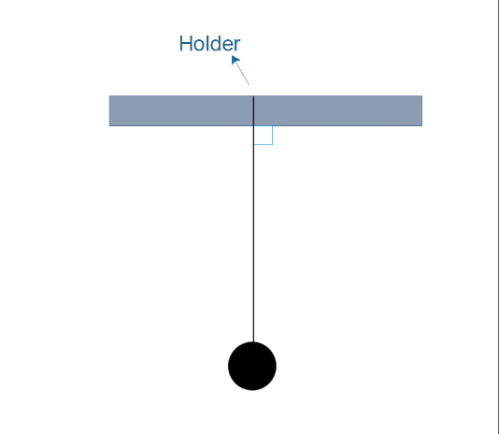

Ruler

# Data & Graph

### Raw data

Table A: Raw Data of length L and periods T

|  |  |  |  |  |  |
| --- | --- | --- | --- | --- | --- |
| **Length (L/m)** | **Uncertainty (m)** | **Trial 1 of ten periods (T1/s)** | **Trial 2 of ten periods (T2/s)** | **Trial 3 of ten periods (T3/s)** | **Uncertainty(s)** |
| 0.400 | ±0.0025 | 12.92 | 13.03 | 13.06 | ±0.01 |
| 0.500 | ±0.0025 | 14.51 | 14.47 | 14.58 | ±0.01 |
| 0.600 | ±0.0025 | 15.96 | 15.93 | 15.81 | ±0.01 |
| 0.700 | ±0.0025 | 17.10 | 17.18 | 17.17 | ±0.01 |
| 0.800 | ±0.0025 | 18.39 | 18.43 | 18.47 | ±0.01 |
| 0.900 | ±0.0025 | 19.64 | 19.77 | 19.64 | ±0.01 |
| 1.000 | ±0.0025 | 20.58 | 20.91 | 20.87 | ±0.01 |

From the raw data, the average ten periods of the three trials is easily calculated by dividing the sum of the data by three,

$$T_{avg}=\frac{T_{1}+T_{2}+T_{3}}{3}$$

Then the average of one period can also be calculated:

$$T=\frac{T_{avg}}{10}$$

The reason for doing so is to gain a better average of the time of one period, as we are not that confident about our ability to judge only one period.

Since the average ten periods of the three trials are repeated measurements, the equation should be:

$$ΔT_{avg}=\frac{T\max{-Tmin}}{2}$$

The uncertainty of the average of one period,

$$ΔT=\frac{ΔT_{avg}}{10}$$

The uncertainty of period squared,

$$ΔT^{2}=\frac{T\max^{2}{-{Tmin}_{}^{2}}}{2}$$

Example 1: the average ten periods of the L=40cm three trials

$T_{avg}=\frac{T_{1}+T_{2}+T_{3}}{3}$ $=\frac{12.92+13.03+13.06}{3}=13.00s$

$$ΔT_{avg}=\frac{T\max{-Tmin}}{2}=\frac{13.06-12.92}{2}=0.07s$$

$$∴T_{avg}=13.00±0.07s$$

Example 2: the average of one period for L=40cm

$$T=\frac{T_{avg}}{10}=\frac{13.00}{10}=1.30s$$

$$ΔT=\frac{ΔT_{avg}}{10}=\frac{0.07}{10}=0.007s$$

$$∴T=1.30±0.007s$$

Example 3: period squared for L=40cm

$$T^{2}={1.30}^{2}=1.69s^{2}$$

$$∆T=\frac{T_{max}^{2}-T_{min}^{2}}{2}=\frac{{1.307}^{2}-{1.293}^{2}}{2}=0.018s^2$$

$$∴T^{2}=1.69±0.018s^2$$

### Processed data

Table B: Processed Data of length L and period squared T^2

|  |  |  |  |  |  |  |  |
| --- | --- | --- | --- | --- | --- | --- | --- |
| **Length (L/cm)** | **Uncertainty (cm)** | **Period squared (T^2/s^2)** |  | **Uncertainty (s^2)** | **Period (T/s)** |  | **Uncertainty(s)** |
| 0.400 | ±0.0025 | 1.69 | ± | 0.018 | 1.30 | ± | 0.007 |
| 0.500 | ±0.0025 | 2.11 | ± | 0.016 | 1.45 | ± | 0.005 |
| 0.600 | ±0.0025 | 2.53 | ± | 0.024 | 1.59 | ± | 0.008 |
| 0.700 | ±0.0025 | 2.94 | ± | 0.014 | 1.72 | ± | 0.004 |
| 0.800 | ±0.0025 | 3.40 | ± | 0.015 | 1.84 | ± | 0.004 |
| 0.900 | ±0.0025 | 3.87 | ± | 0.026 | 1.97 | ± | 0.006 |
| 1.000 | ±0.0025 | 4.32 | ± | 0.069 | 2.08 | ± | 0.017 |

|  |  |  |  |  |  |  |
| --- | --- | --- | --- | --- | --- | --- |
| **Average 10 periods (Tavg/s)** |  | **Uncertainty(s)** | **Trial 1 (T1/s)** | **Trial 2**  **(T2/s)** | **Trial 3 (T3/s)** | **Uncertainty(s)** |
| 13.00 | ± | 0.07 | 12.92 | 13.03 | 13.06 | ±0.01 |
| 14.52 | ± | 0.05 | 14.51 | 14.47 | 14.58 | ±0.01 |
| 15.90 | ± | 0.08 | 15.96 | 15.93 | 15.81 | ±0.01 |
| 17.15 | ± | 0.04 | 17.10 | 17.18 | 17.17 | ±0.01 |
| 18.43 | ± | 0.04 | 18.39 | 18.43 | 18.47 | ±0.01 |
| 19.68 | ± | 0.06 | 19.64 | 19.77 | 19.64 | ±0.01 |
| 20.79 | ± | 0.17 | 20.58 | 20.91 | 20.87 | ±0.01 |

According to the graph, L and T^2 have a linear relationship, with the gradient of the line 4.2672.

According to the formula T2 = 4π2L/g is m, the expected value is 4π2/g, which equals 4.02, with the percent error of $\frac{4.27-4.02}{4.02}×100\%=6.2\%$.

Then the calculated value is used to calculated g,

$$\frac{4π^{2}}{g}=4.27$$

$$4π^{2}=4.27g$$

$$g≈9.25$$

The percent error is $\frac{9.81-9.25}{9.81}×100\%=5.7\%.$

### Possible sources of error

The data is almost consistent with the formula T2 = 4π2L/g.

There are several possible reasons that causes those errors.

1. The errors may due to the amplitude. Even though it was controlled, the starting angle might not be that precise.
2. It is noticed that the movement of the pendulum was not always on a plane Instead there was a rotation, and that might cause the discrepancy.
3. The string tied to the clamp might move while doing the experiment.
4. The experiment was greatly influenced by the human reaction time and air resistance. Since 10 periods were measured every time, the human reaction time might be reduced, but the air resistance could slow down the pendulum.

To minimize the errors that occurred in this experiment, there are several following ways:

1. Use protractor to measure the angle instead of the triangle ruler: let the pendulum be in the equilibrium position and align the string with the zero graduation. Then measure the angle.
2. Let the pendulum fall by itself without pulling or pushing it.
3. Use the clamp to hold the string tightly instead of just coiling it on the stand.
4. Use a heavier yet smaller metallic ball to do the experiment can help reduce the air resistance.

# Conclusion

In this experiment, the aim was to determine the effect of length of pendulum on its period. It is hypothesized that the period squared T^2 is proportional to the length L. After performing the experiment and doing several trails, the hypothesis got confirmed. Although the measured value of g differed from the actual value by a few percent because of different sources of error, this difference was very small, leading to the conclusion that as the length of the string increases, the period of the pendulum will also increase. And the formula for that is T = 2π√(L/g).

variables affect the time of the pendulum swing: length of string and angle measure. The mass, however, does not